Step 1:
HW5 builds on HW4's Service 1 and Service 2. Service 1 was modified to add Cloud SQL integration and timing instrumentation. Service 2 is unchanged.

Step 2 — Schema
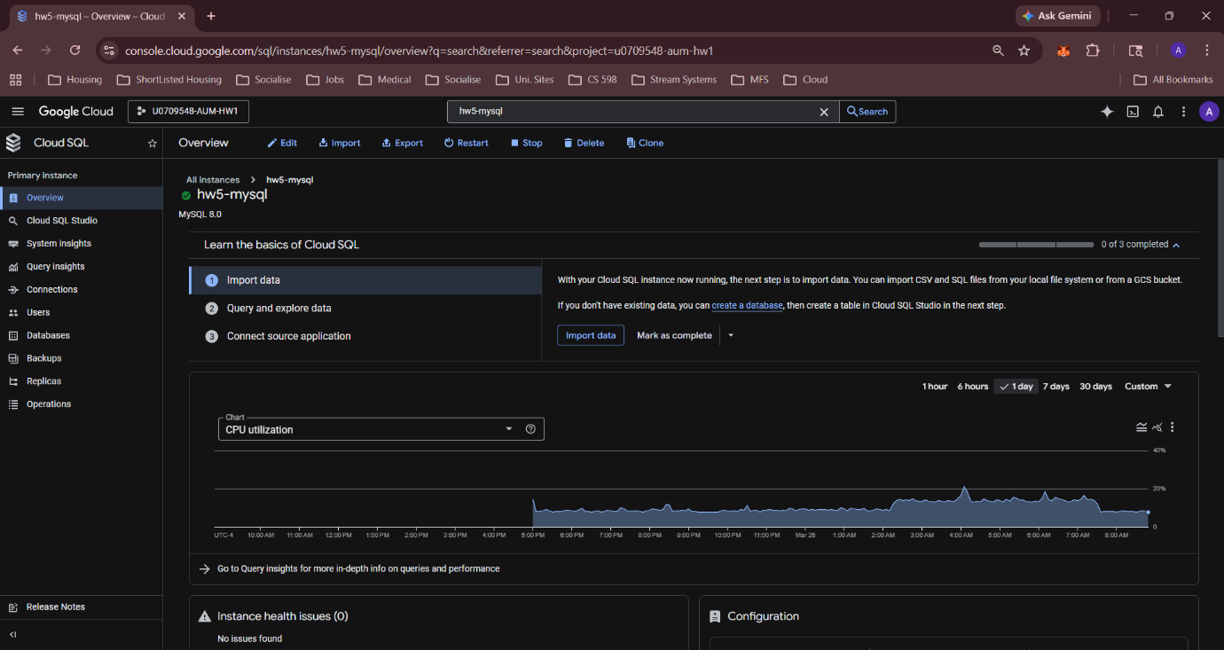
Screenshot of Cloud SQL instance hw5-mysql in GCP Console (RUNNABLE)

Write the two tables:
requests: id, created_at, country, client_ip, gender, age, income, is_banned, time_of_day, requested_file, PRIMARY KEY(id)
errors: id, created_at, requested_file, error_code, PRIMARY KEY(id)

Step 3 —
Service 1 extracts X-country, X-gender, X-age, X-income, X-time, X-client-IP headers.
Successful requests insert into requests table. Failed requests (non-200) insert into errors table.
VM1 uses hw5-service1-sa with roles/cloudsql.client permission and Cloud SQL Auth Proxy v2 running as a systemd service.

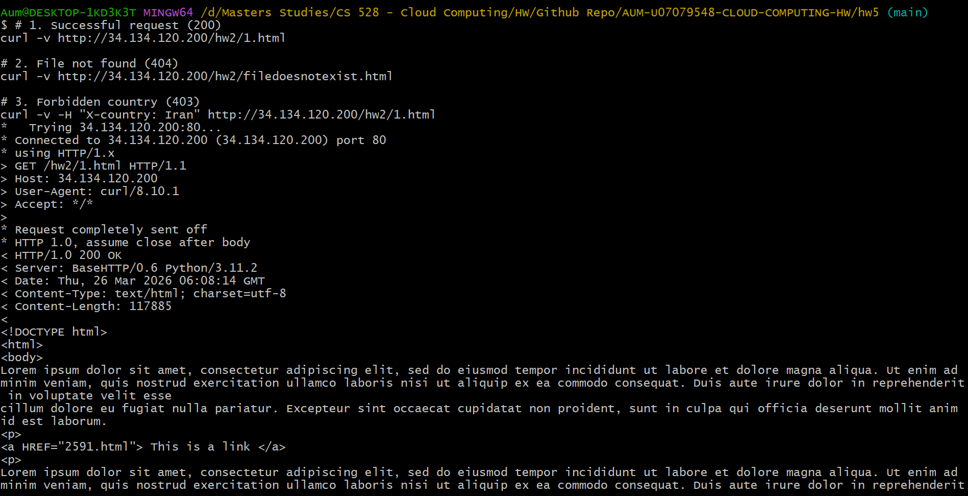
Step 4 — curl screenshots

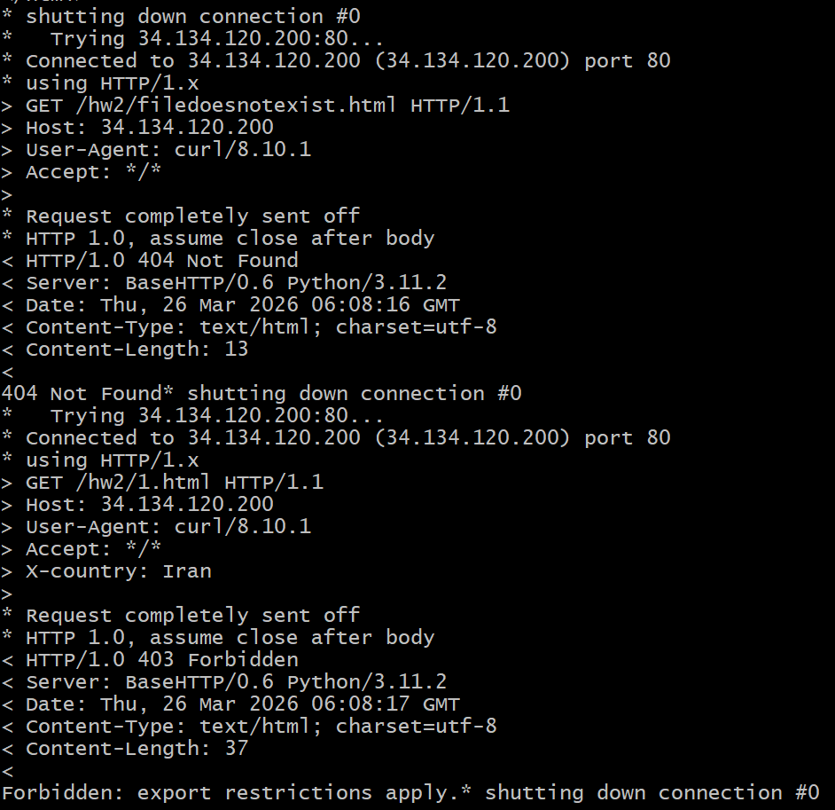

HTTP/1.0 200 OK → curl http://34.134.120.200/hw2/1.html
HTTP/1.0 404 Not Found → curl http://34.134.120.200/hw2/filedoesnotexist.html
HTTP/1.0 403 Forbidden → curl -H "X-country: Iran" http://34.134.120.200/hw2/1.html
The DB output showing rows in both tables after the requests.
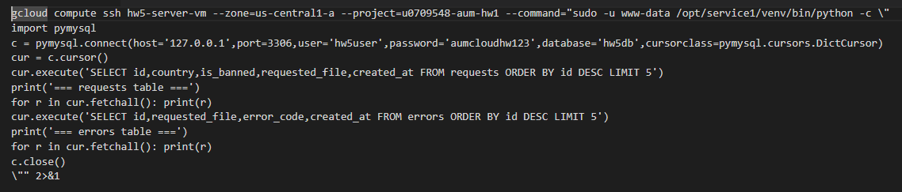
COMMAND:

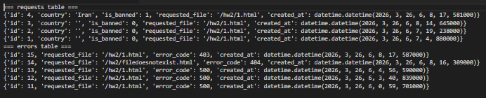

Step 5 — VM + 2 clients

Screenshot of VM1 in GCP Console showing e2-standard-2
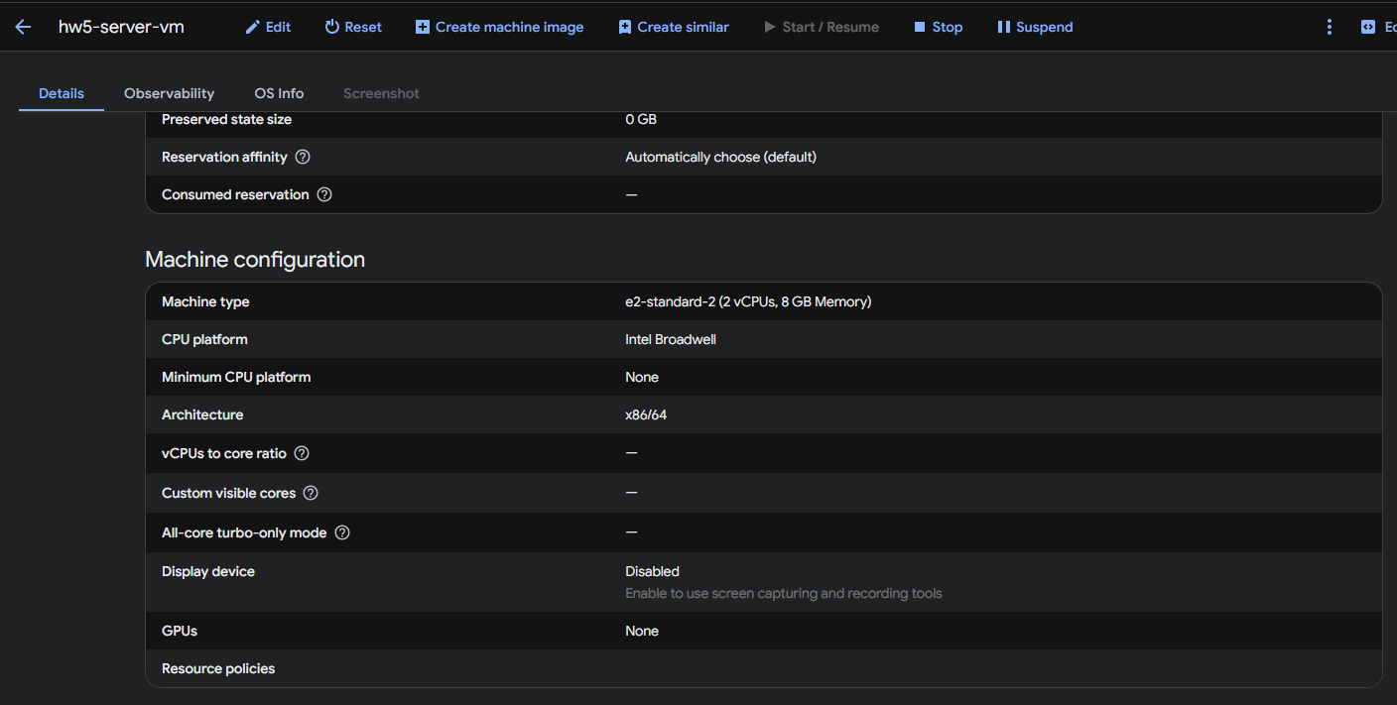

Screenshot of both client terminals running simultaneously
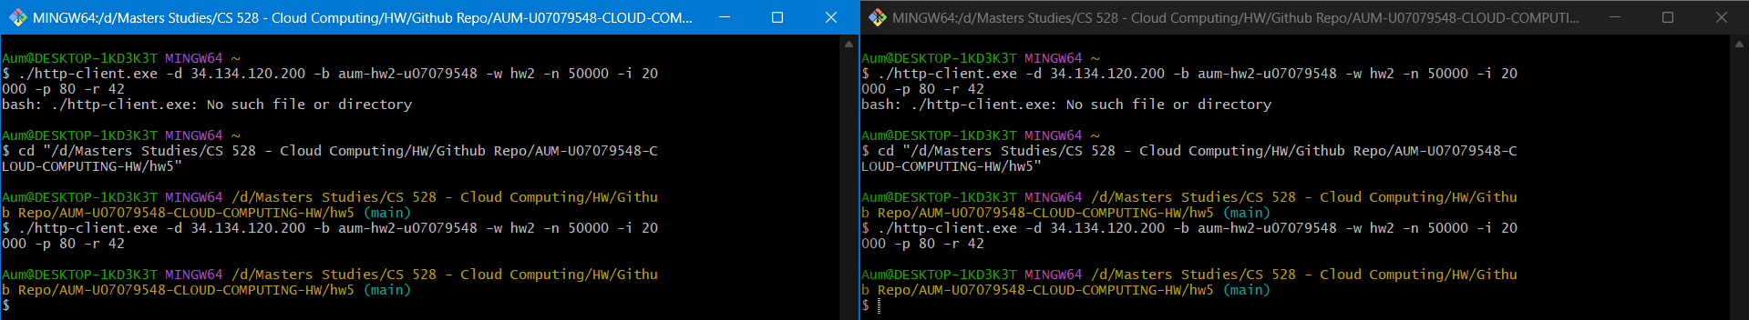

Write: "VM1 uses e2-standard-2 (2 vCPUs, 8GB RAM) to handle 2 concurrent clients. Both clients used seed 42 and sent 50,000 requests each (100,000 total)."
Step 6 — Timing instrumentation
Service 1 instruments 4 separate operations using time.perf_counter_ns():
extract_headers() — time to parse HTTP request headers
read_file_from_gcs() — time to download file from Cloud Storage
send_response_body() — time to write HTTP response to client
insert_request() / insert_error() — time to insert row into Cloud SQL
Timings are logged to Cloud Logging as REQUEST_TIMING events in milliseconds.
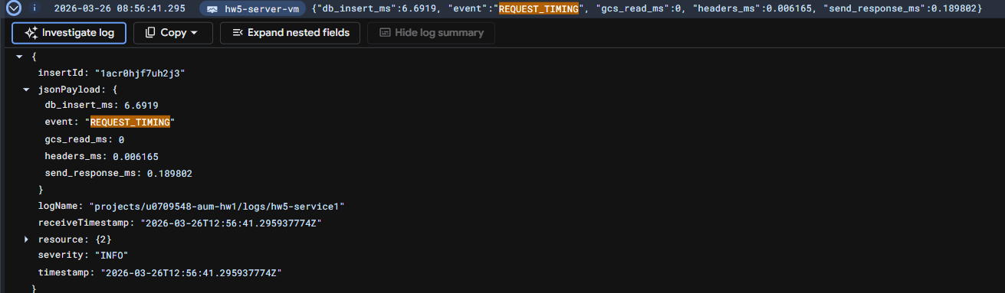

Step 7 — Statistics
COMMAND : DB_HOST=136.113.97.153 DB_NAME=hw5db DB_USER=hw5user DB_PASSWORD=aumcloudhw123 /c/Python313/python.exe query_stats.py
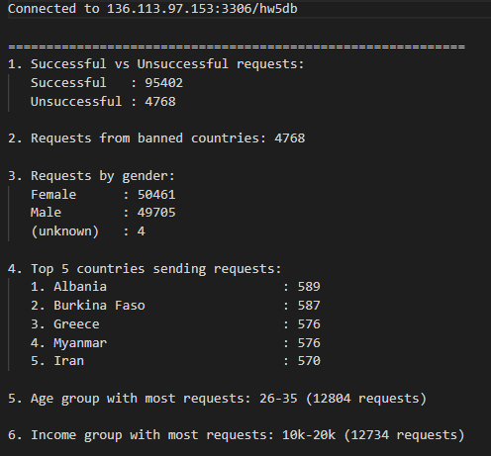

Successful: 95,402 / Unsuccessful: 4,768
Requests from banned countries: 4,768
Male: 49,705 / Female: 50,461
Top 5 countries: Albania, Burkina Faso, Greece, Myanmar, Iran
Age group with most requests: 26-35 (12,804 requests)
Income group with most requests: 10k-20k (12,734 requests)
Step 8 — Cloud Function (Could not capture SS from GCP since I had already ran the cleanup script)
Screenshot of stop-idle-db Cloud Function in GCP Console (ACTIVE) from the setup script
Screenshot of Cloud Scheduler job showing 0 * * * * from the setup script
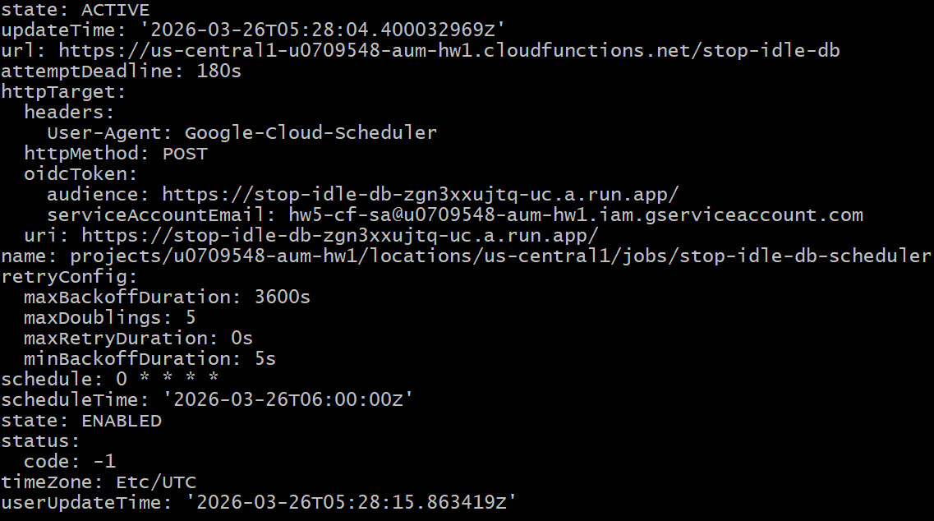

A Cloud Function checks hourly if the DB is RUNNABLE and stops it by setting activationPolicy=NEVER. Triggered by Cloud Scheduler every hour to prevent unnecessary billing.
Step 9 — Setup/Cleanup scripts
Run bash setup.sh from the hw5/ directory. Project ID is hardcoded as u0709548-aum-hw1. The script creates Cloud SQL, Pub/Sub, service accounts, VMs, and deploys the Cloud Function automatically. Run bash cleanup.sh to tear down all resources.
Setup Script Run:
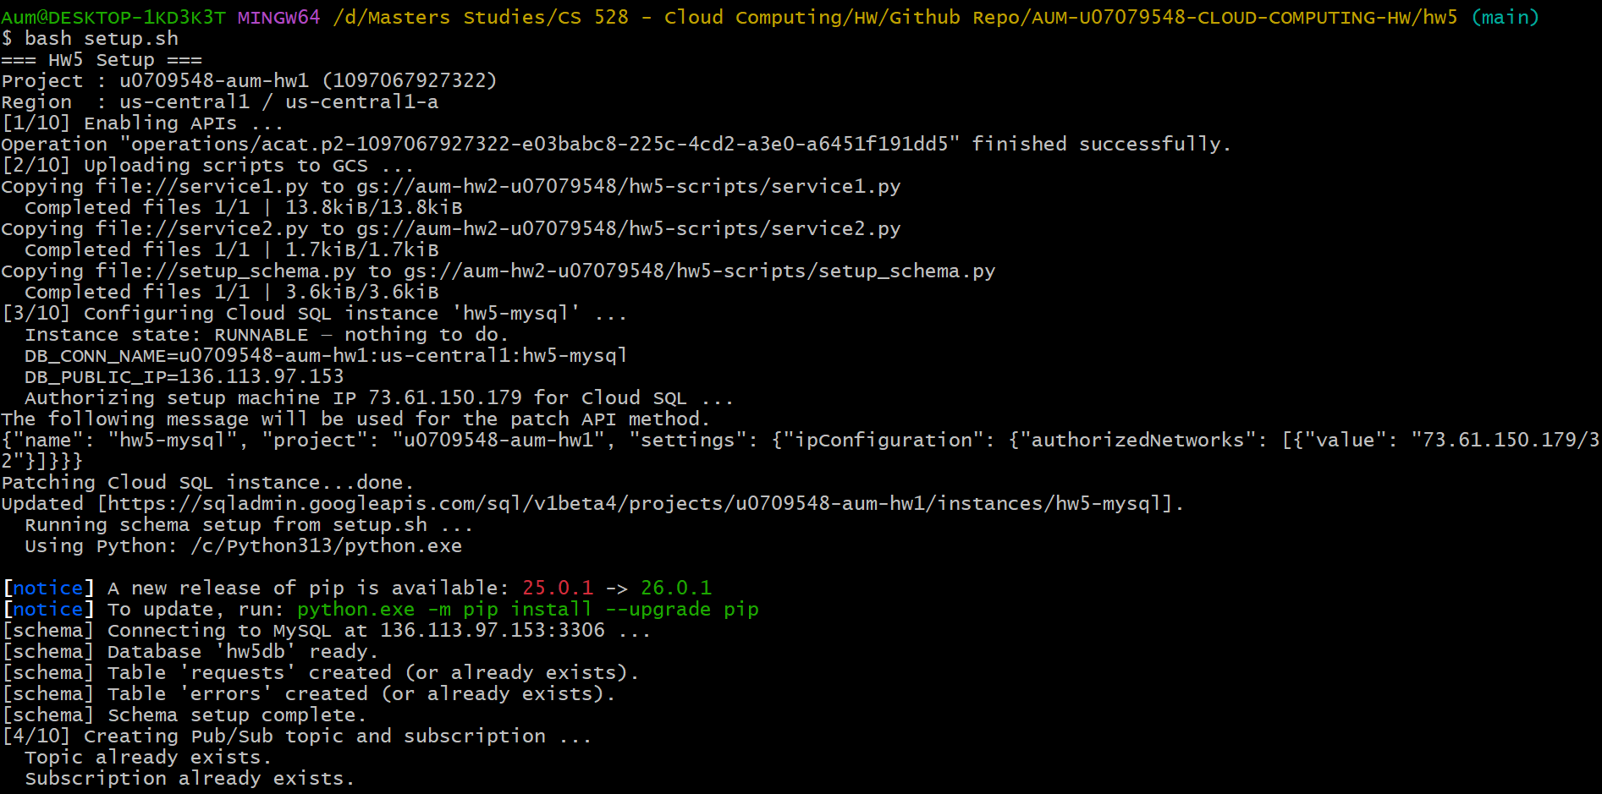

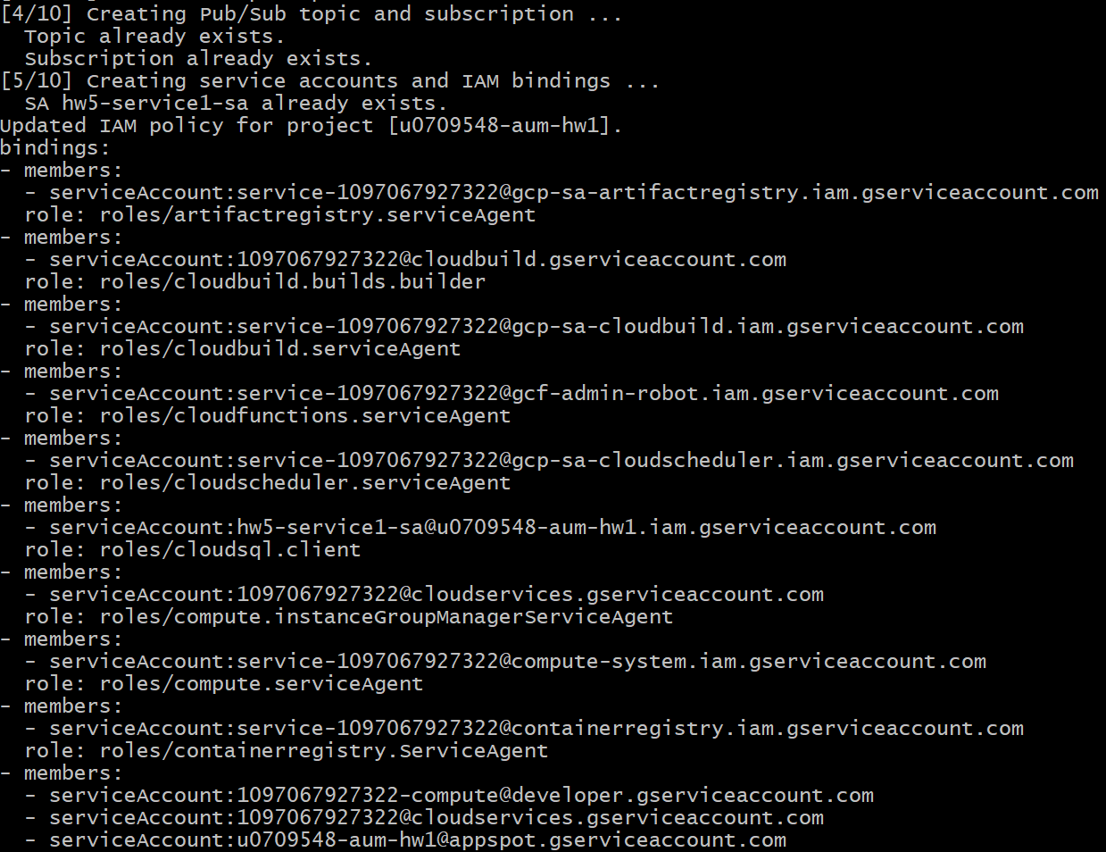

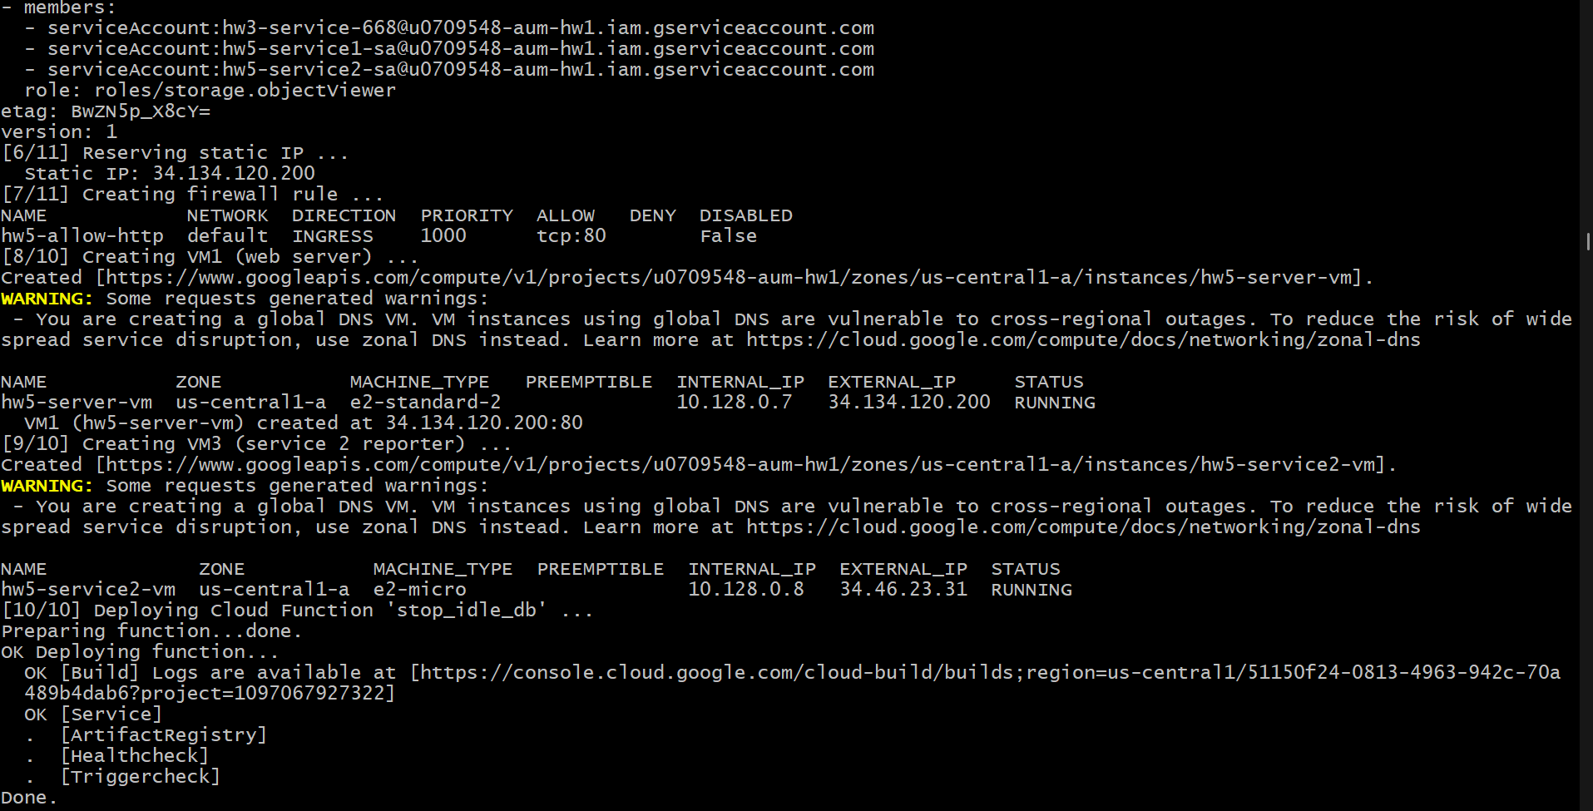

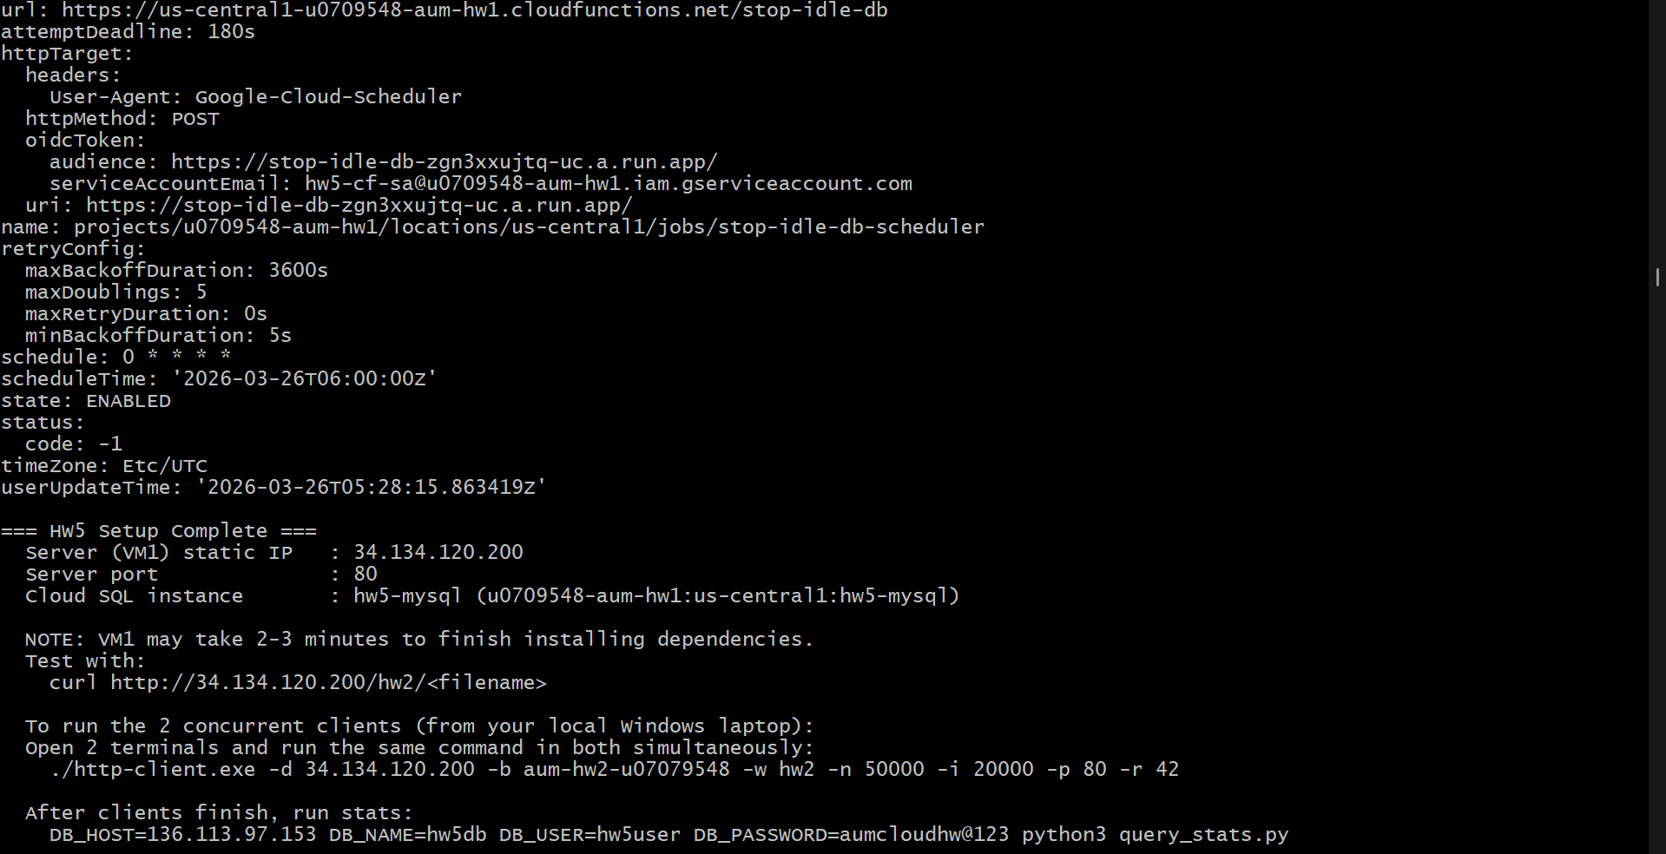

Cleanup Script:

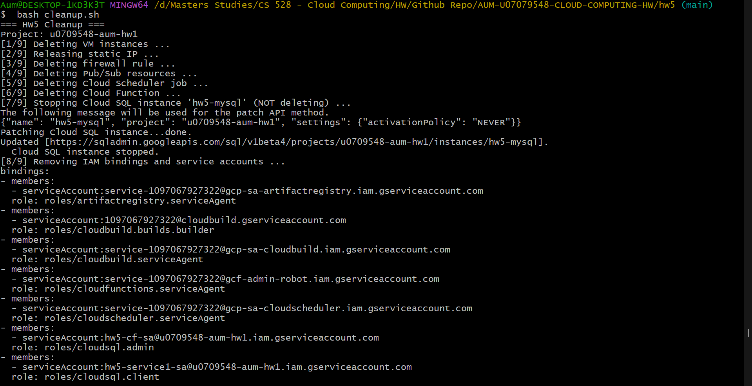

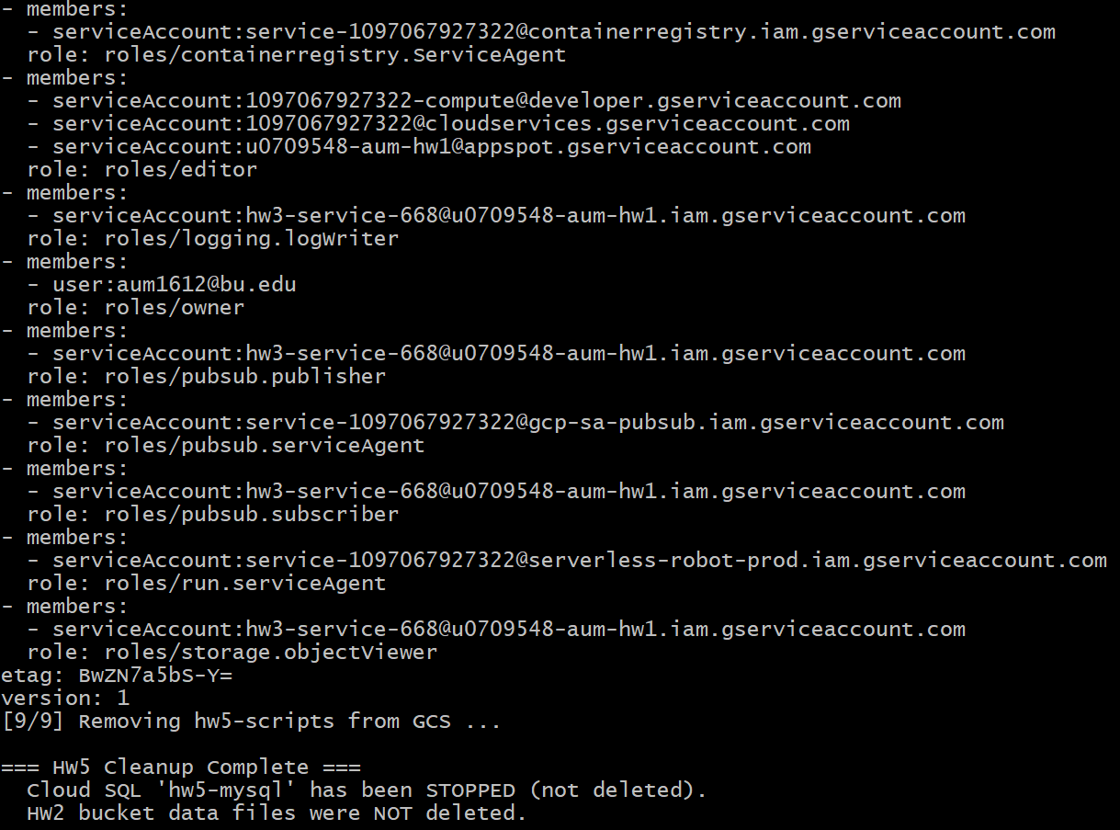

Github Link - https://github.com/aumghelani/AUM-U07079548-CLOUD-COMPUTING-HW/tree/main/hw5
https://github.com/aumghelani/AUM-U07079548-CLOUD-COMPUTING-HW.git

